

**Coffee Shop Data Analysis Project using Excel**

**2024**

**Created by: Lama Ibrahim Al-Marhabi**

**Introduction**  
 Imagine running a coffee shop that welcomes hundreds of customers every day, where the aroma of freshly brewed coffee blends with the sound of friendly conversations. Behind this lively scene flows a massive amount of data—ranging from sales figures and customer preferences to branch performance and customer satisfaction levels.

In a competitive world like this, success lies in transforming data into clear stories that guide better decision-making. By leveraging **advanced analytics**, **exploratory data analysis (EDA)**, and **statistical modeling**, along with tools such as **Power BI** and **Tableau**, we turn raw numbers into actionable insights that speak for themselves.

Through this analysis, we dive deep into hidden patterns within daily operations, uncovering what makes certain products successful and identifying areas for improvement. Imagine having a dashboard that instantly shows which branches are the most profitable and how customer preferences shift throughout the week.

Our goal is not just to enhance performance but also to deliver an exceptional customer experience and strengthen relationships with suppliers. This analysis transforms challenges into growth opportunities, ensuring that our coffee shop doesn’t just keep up with the market—but thrives at its core.

### **Report Objective**

Imagine you are running a bustling café in the heart of Saudi Arabia, where the rich aroma of fresh coffee fills the air, and customers flock at various times, eagerly awaiting their favorite drinks. Behind these delightful moments lies a story told through numbers and data, waiting to be analyzed to uncover what truly happens behind the scenes. This report takes you on a deep dive into the world of data, exploring when customer traffic peaks, which branches excel, and what products captivate customers’ tastes. Our goal is to transform these numbers into smart decisions that propel the business toward success and enhance its competitiveness in the market.

### **Importance of Analysis**

Every time a cup of coffee is sold or a new order is placed, an opportunity arises to gain deeper insights into market behaviors. The significance of this analysis lies in its ability to provide a comprehensive view that helps answer critical questions: When are the branches most active? Who are the standout employees? What products ensure repeat visits and boost revenue?

* **Performance Improvement**: The analysis sheds light on hidden successes and missed opportunities, enhancing performance across every branch.
* **Strategic Planning**: Planning for the future becomes easier when we understand past patterns and how market behaviors evolve.
* **Intelligent Resource Management**: When resources are optimally managed—from identifying peak hours to distributing staff—it becomes possible to achieve a better return on investment.
* **Effective Risk Management**: By anticipating potential challenges, proactive strategies can be implemented, making the business agile in the face of unforeseen disruptions.

### **Analysis Tools**

**Behind every insightful vision is a tool that transforms numbers into comprehensible stories. To achieve this, we utilize a range of tools that make data analysis an engaging journey:**

* **Power Query:** The magic key that cleans and organizes the data, ready to embark on the analytical adventure.
* **Power Pivot:** A powerful tool that enhances data analysis capabilities, allowing users to efficiently manage and analyze large and complex data models.
* **Pivot Tables:** These tables act as a magnifying glass, helping us quickly classify vast amounts of data to understand trends and finer details.
* **Power BI:** This tool transforms data into interactive visual dashboards, making pattern recognition easy and enjoyable.

**Phase 1: Data Preparation**

* **Data Cleaning**

We will use the **Power Query** tool in this phase to effectively clean and organize the data.

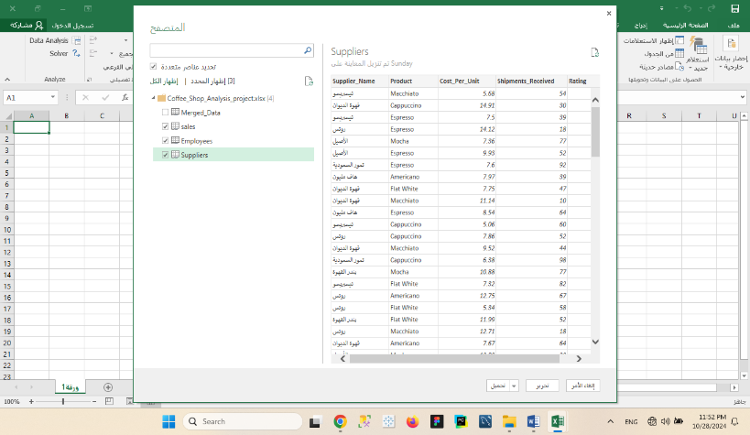

* **Missing Values**

The dataset contains no missing or incomplete values, indicating that it is well-organized and will support logical analysis. Clean and complete data ensures smooth processing, reduces the need for assumptions or imputation, enhances the accuracy and reliability of results, and enables more effective decision-making.

* **Duplicates**

I removed duplicates from the **employee ID** column to prevent errors such as incorrect reports or data conflicts. This step ensures data consistency, enhances its reliability, and contributes to improving the accuracy of the final analysis.

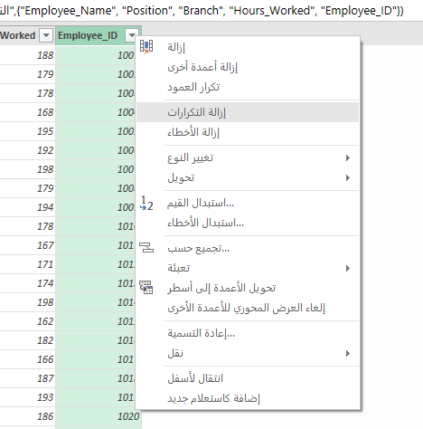

* **Formatting**

Changing letter case to uppercase during the data cleaning phase contributes to standardizing the format, reducing errors, and increasing analysis accuracy. This practice facilitates searching and comparing values, improves the accuracy of grouping and classification, and enhances the professionalism of visual presentations. Consequently, using a unified letter case ensures data quality and ease of handling in subsequent stages of analysis.

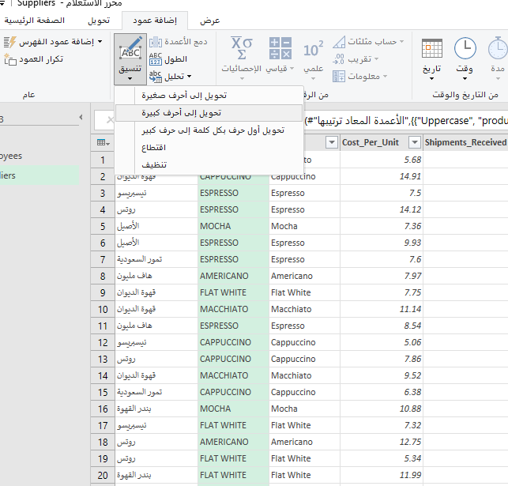

* **Transform Data Types**

I converted each column to its appropriate data type, which enhances analysis efficiency and ensures the accuracy of calculations and queries. This conversion reduces potential errors during processing and facilitates logical understanding and analysis of the data.

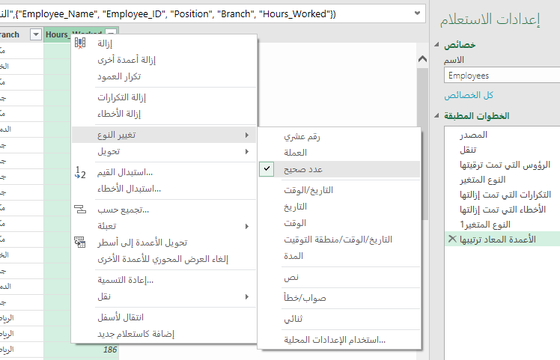

* **Grouping Data**

### **Aggregating Revenue and Profit by Branch**

* **Objective:** Understand the financial performance of each branch.
* **Process:**
  + **Group By:** Branch.
  + **Calculations:**
    - Sum of Revenue.
    - Sum of Profit.
* **Analysis:** This helps identify the most profitable branches

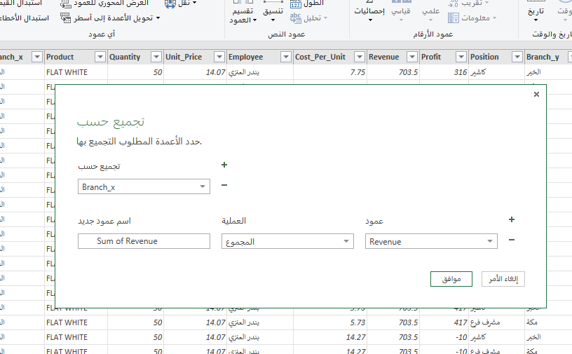

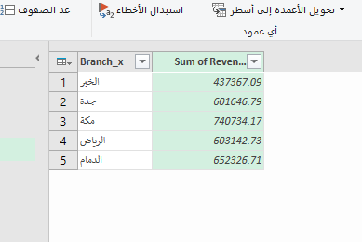

## 

## 

### **Aggregating Products by Type and Analyzing Performance**

* **Objective:** Identify the best-selling and most profitable products.
* **Group By:** Product.
* **Calculations:**
  + Sum of Quantity.
  + Sum of Revenue.
  + Average Profit.
* **Analysis:** Identify products that need more promotion or those generating the highest returns.

## 

## 

* **Add Custom Columns**

### **Aggregating Suppliers by Costs**

* **Objective:** Identify the suppliers with the highest costs to the company.
* **Group By:** Supplier (from the **Suppliers sheet**).
* **Calculations:**
  + Total Cost per Supplier (**Sum of Cost_Per_Unit * Quantity**).
* **Analysis:** Helps enhance negotiation with suppliers.

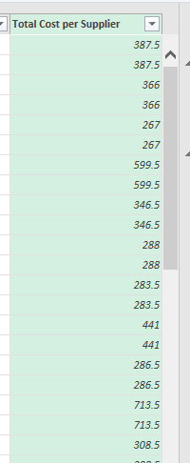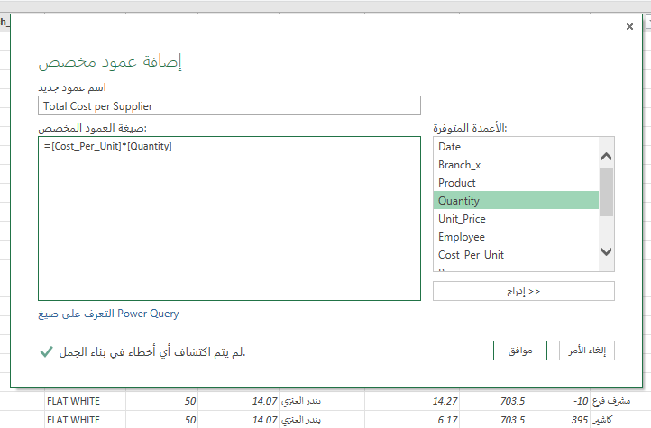

### **Profit Margin**

* **Formula:** (Profit / Revenue) * 100
* **Objective:** Determine the profit percentage for each sale.

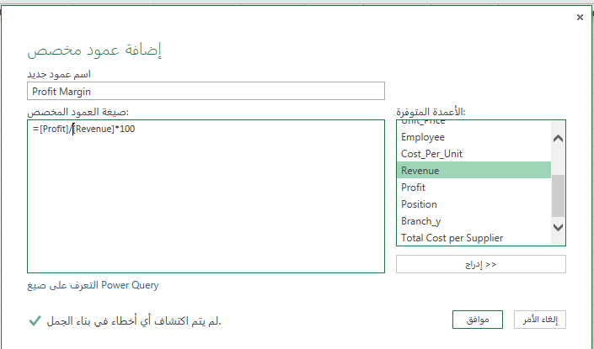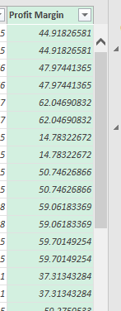

* **Advanced Analysis with Filters**

### **1. Branch Filtering:**

* **Objective:** Analyze the performance of each branch individually, such as branches in the Central Region or Riyadh, to determine which generate the highest revenue and profit.

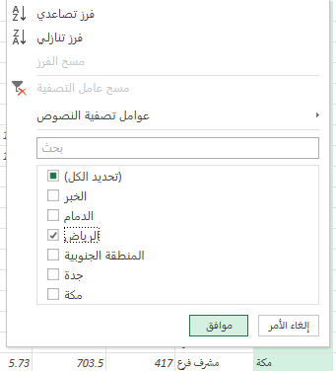

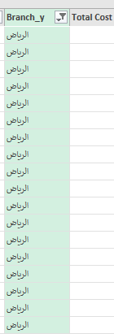

### **2. Date Filtering:**

* **Objective:** Use time-based filters, such as:
  + Monthly analysis (January, February)
  + Quarterly analysis (Q1, Q2)
  + Annual analysis to identify seasonal trends.

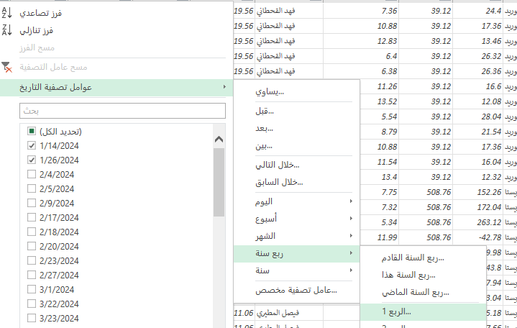

### **3. Product Filtering:**

* **Objective:** Identify the best-selling or underperforming products to improve purchasing decisions.

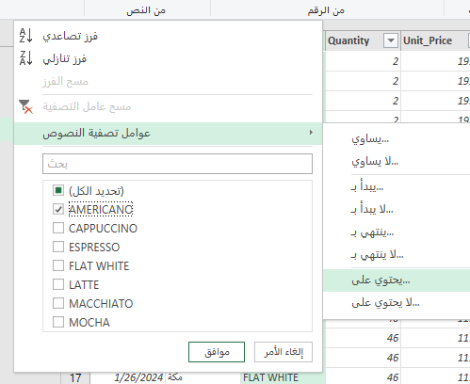

### **4.Profit Margin Filtering:**

* **Objective:** Extract products with a profit margin higher than a specific threshold (e.g., 20%).

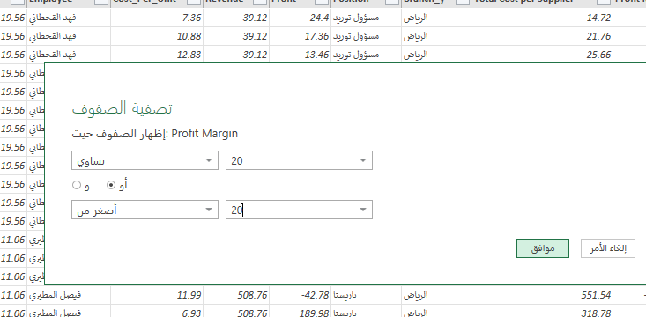

* **Data Merging**

Excel File with Three Tables:

* **Table 1:** Sales Data - Contains information about sales transactions, including date, amount, and product details.
* **Table 2:** Employee Data - Includes details about employees, such as names, roles, and efficiency metrics.
* **Table 3:** Supplier Data - Provides information on suppliers, including names, contact details, and contributions to products.

The data used in this report originates from a Saudi coffee shop listed on the **Saudi Open Data Portal**. This dataset provides valuable insights into the shop’s performance, enabling a comprehensive analysis of sales, employee efficiency, supplier contributions, and product profitability.

**Phase 2: Data Modeling**

**Power Pivot**: We will use this tool to analyze large datasets and create complex data models, enhancing performance and supporting DAX, which facilitates integration with Excel.

* **Modeling and Relationships**

We placed the tables in the model and linked them through unique values to ensure consistent analysis.

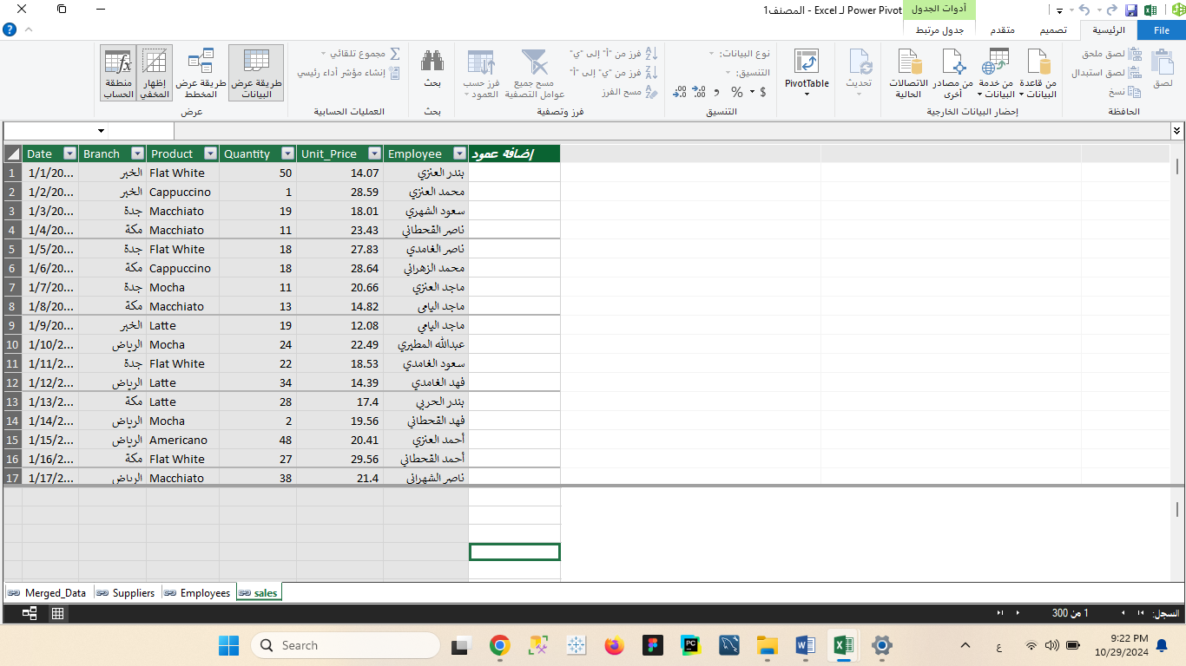

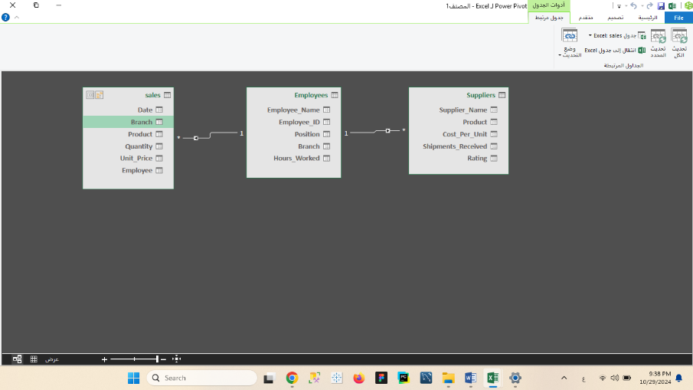

* **Calculations**

### **Average Unit Price for Each Product**

* **Formula**:  
  Average Unit Price=RevenueQuantity Sold\text{Average Unit Price} = \frac{\text{Revenue}}{\text{Quantity Sold}}Average Unit Price=Quantity SoldRevenue​
* **Objective**:  
  To analyze prices and ensure consistency in product pricing.

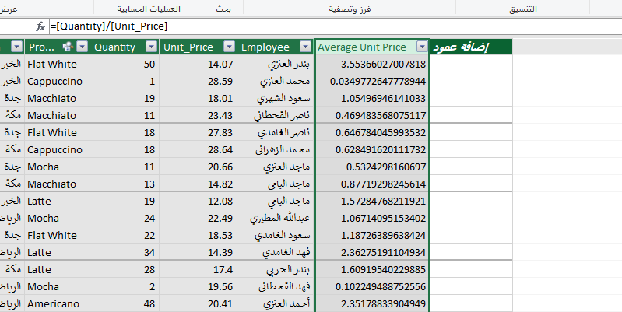

We used the **RELATED** function to retrieve related data from another table, ensuring accurate pricing analysis by linking product details with sales data.

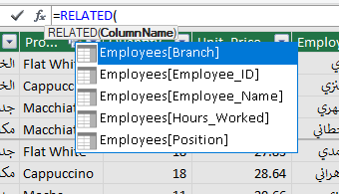

* **Measurements**

We used the **SUM** function to calculate the total working hours for employees throughout the year.

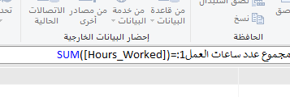

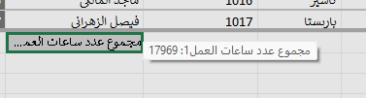

**Phase 3: Data Distributions**

In this phase, we will use the **Pivot Table** tool to easily analyze and aggregate data, providing accurate insights and saving time in report creation.

### **How to Start Analytical Questions**

To analyze data using a **Pivot Table**, it must be classified into:

1. **Quantitative Data**: Numeric data like revenue or working hours, used in **values** to calculate sums or averages.
2. **Qualitative Data**: Categorical data like department names or order statuses, used in **rows or columns** to group data.

**Q1:Who are the top 5 employees based on sales volume?**

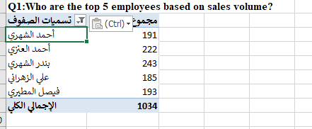

**Q2: Who are the highest-rated suppliers?**

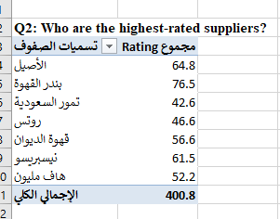

Q3: **What is the total revenue generated by each employee for every 100 hours worked?**

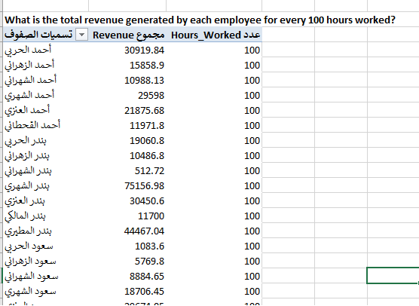

**Q4: How does branch performance vary by product category and individual product?**

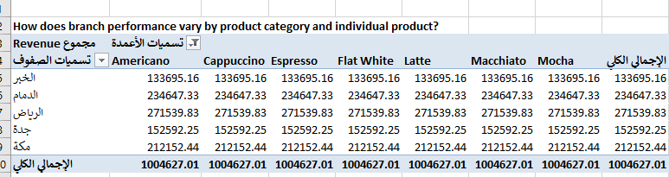

**Phase 4: Data Visualization**

In this phase, we will use **Power BI** for creating interactive and visually appealing data visualizations, enabling deeper insights and facilitating informed decision-making.

* We have completed the first step by importing the data and tables into **Power BI**, aiming to build a dashboard that will support informed decision-making.

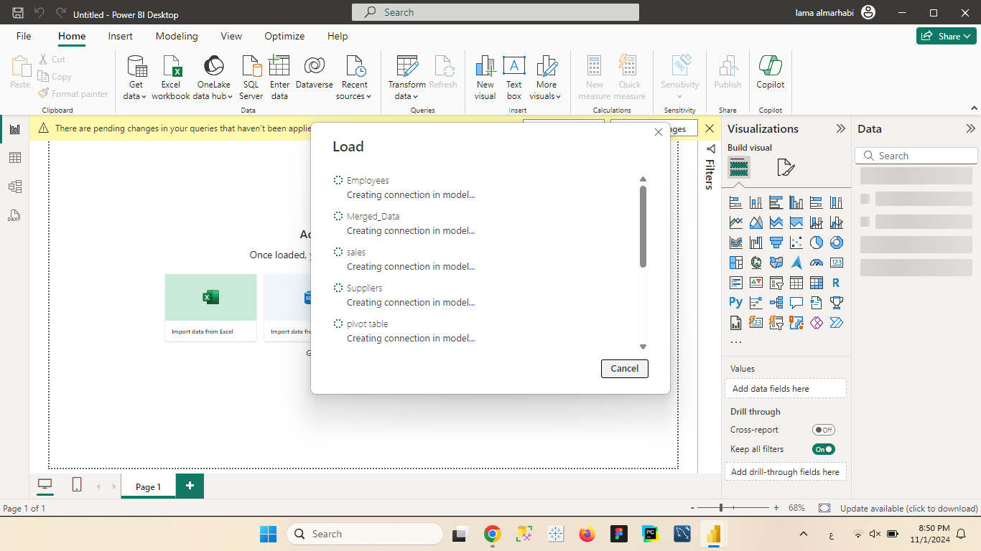

* **Customer Behavior Analysis Dashboard"**
* The most popular drinks are displayed according to the branches

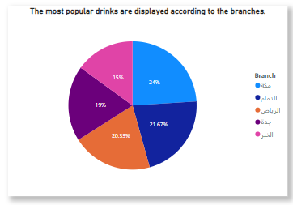

* Shows the profit line for the products.

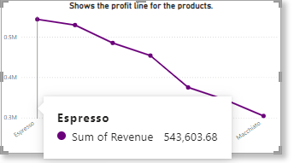

* Product Evaluation

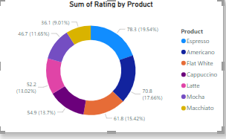

* We have completed the first dashboard, and I hope it has achieved strong analytical goals and contributed to making the right decisions regarding sales, employee performance analysis, and suppliers.

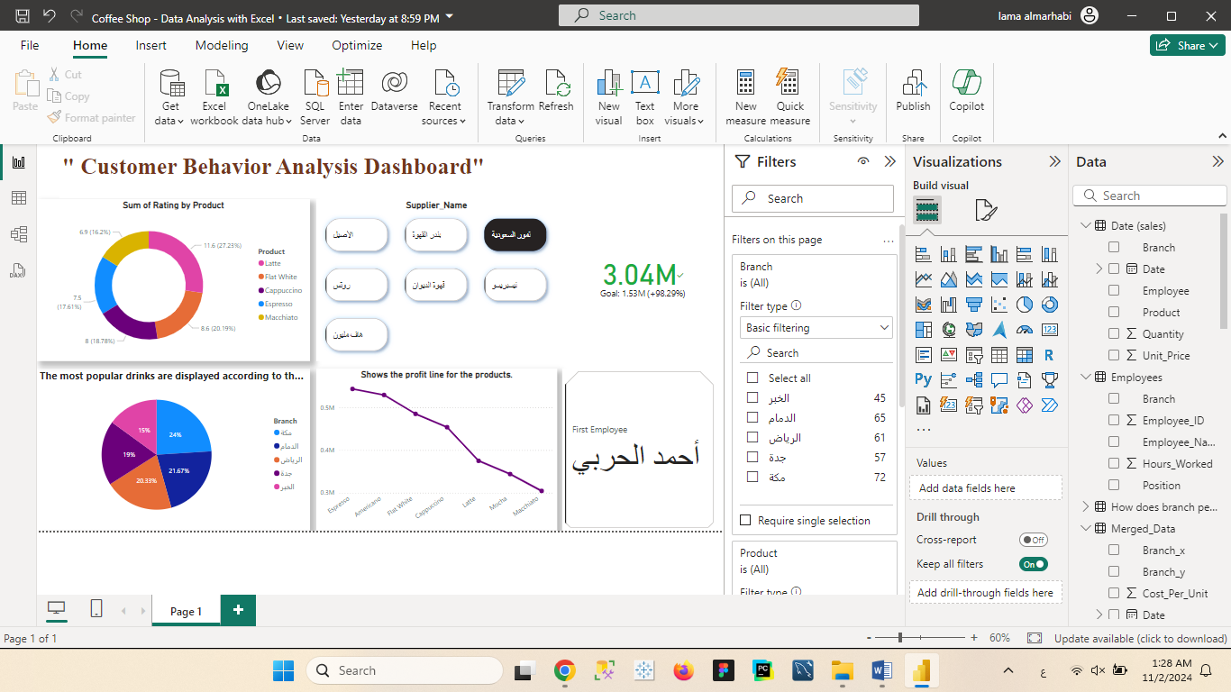

This is the initial draft of the dashboard, presented without formatting or colors. The purpose of this step is to provide a clear overview of the general concept and to navigate through different elements of the dashboard. This allows for reviewing the initial idea and ensuring it aligns with requirements. Following this stage, final formatting and colors will be applied to enhance the dashboard’s appearance and make the data clearer and more visually appealing.

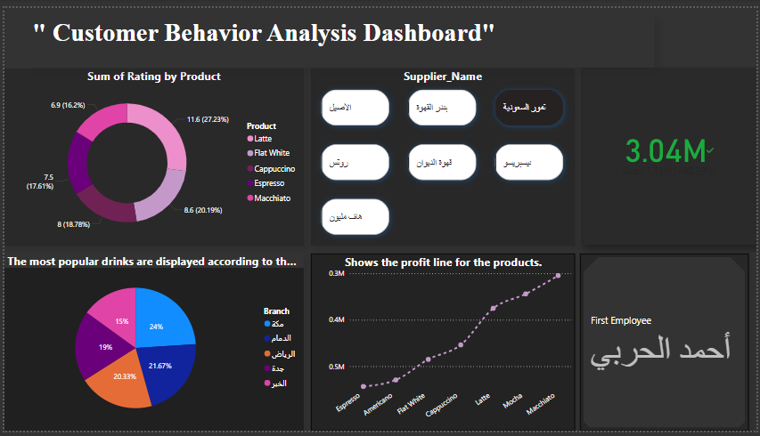

Imagine a dashboard that tells a complete story of customer behavior, opening a window into their preferences, experiences, and the products they favor at each branch. The story begins with the "Sum of Rating by Product" chart, which reveals satisfaction levels for each drink, helping us understand which items leave the best impression on customers.

Next, we move to the "Most Popular Drinks by Branch" chart, allowing us to see how customer preferences vary across branches in Mecca, Riyadh, Jeddah, and Al-Khobar. This insight enables us to tailor offers and guide marketing strategies more accurately for each region.

As we dive deeper, we find the supplier section neatly organized, making it easy to monitor supply chains and perform comparisons, supporting us in making informed decisions about strengthening partnerships with key suppliers.

Finally, the product profitability chart appears, showing the journey of each product’s profits, allowing us to identify which items contribute the most to revenue growth.

This cohesive dashboard tells a data story through a visually connected structure, enhancing our ability to understand the market and make well-informed, strategic decisions.

**Conclusion**

After weeks of intensive work on data cleaning and conducting complex analyses, a comprehensive report was prepared, providing a clear picture of the coffee shop's journey toward success.

The report began by analyzing monthly revenues, identifying intriguing seasonal patterns. As winter approached, a noticeable increase in sales of hot beverages was observed, while ice cream sales declined.

The analysis then shifted to employee performance, revealing a distinguished group of baristas who contributed to the highest sales figures. At the same time, the report highlighted some employees who needed additional training to enhance their service levels.

A thorough analysis of supplier performance was also conducted, demonstrating the importance of continuing partnerships with key suppliers due to their product quality and competitive purchasing costs. The recommendations included advice on negotiating better prices with some suppliers.

In the end, the findings and recommendations offered a pathway to enhance the project's profitability and increase customer loyalty in the coming years, opening new horizons for performance improvement and sustainable growth.